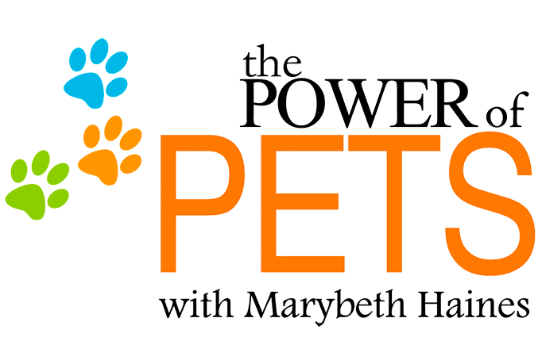

Dear friend,

If you are reading this letter right now, I wish to extend my heart out to yours in honour and remembrance of the pets you have had in your life with a loving embrace and share my warmest condolences. Receiving true, unconditional love from another sentient being such as a dog, cat, horse, ferret, bird, fish, rabbit, frog, snake or otherwise (the list is much longer than this), is something that can only be explained by someone who has experienced the vastness of this type of love. And if there was one thing that I could say to you at this very time, I’d wish to tell you how sorry I am for your loss.

There are two things I wish to also sincerely thank you for. The first, is for your love of animals and how much you care for them. The second, is for how you have given them a place of love, compassion and happiness. I truly believe that animals come into our lives for a reason and as our teachers, they share much wisdom and many lessons for us to learn. Would you agree with this sentiment?

We’ve all heard the saying “Pets are angels with wings” and it’s so true isn’t it? Animals don’t judge or criticize, they only love and ask for love in return. They are our friends, family and confidants. Your pet made a difference during his/her time here on earth. A legacy has been created and will always be honoured. To make a lasting impression on just how important your beautiful animal is, I heart-fully invite you to share his/her story as a WOW Pet Angel.

This beautiful tribute is a collaboration of love that my friend and colleague Marybeth Haines (Animal Communicator & Author of the Power of Pets Book & resources) myself Carolyn Shannon (Founder/Owner of WOW Pet Angels) partnered together to say thank you to the amazing animals of our world and to you, their guardian who loves them so. It’s a way to create something that originates directly from the source of the love animals share and how they share them unconditionally. I am truly grateful to be a sponsor of this caring initiative.

To make this process as helpful as possible, we have created this form for you to use as a guide in hopes that it can be a gentle aide to you, as you share your words of honour on behalf of your beloved pet. Please feel free to use as you see fit. It is just a guide and you are welcome to use other paper/format should you wish.

Form on next page…

SIMPLY FILL IN, SAVE WITH YOUR PET’S NAME IN TITLE & RETURN TO EMAIL BELOW:

WOW Pet Angel Tribute Submission
**Please include 2 photos of your pet
**Your tribute may include up to 1,000 words max
**Please include a first and last name for your pet

- Your Name:

- Your Email Address:

- Your Pet’s Name: First: Last: (usually family name)
- How did you meet your pet? How did they come into your life?

- What does your pet mean to you?

- What did you learn from them? What did they teach you?

- Anything else you might like to share? Fun or touching memories?

**Please email your completed tribute and two photos to Carolyn
thewomenofworthmagazine@gmail.com

Thank you for taking the time for this. May it be healing and helpful to your heart.

1. For more information please visit Carolyn Shannon’s WOW Pet Angel Website at:
https://www.wowpetangels.com.

2. To view some examples of WOW Pet Angel Tributes, please visit:
https://www.wowpetangels.com/w-hardy.php
https://www.wowpetangels.com/mmidnight.php

3. Main page of tributes: https://www.wowpetangels.com/2019.php

